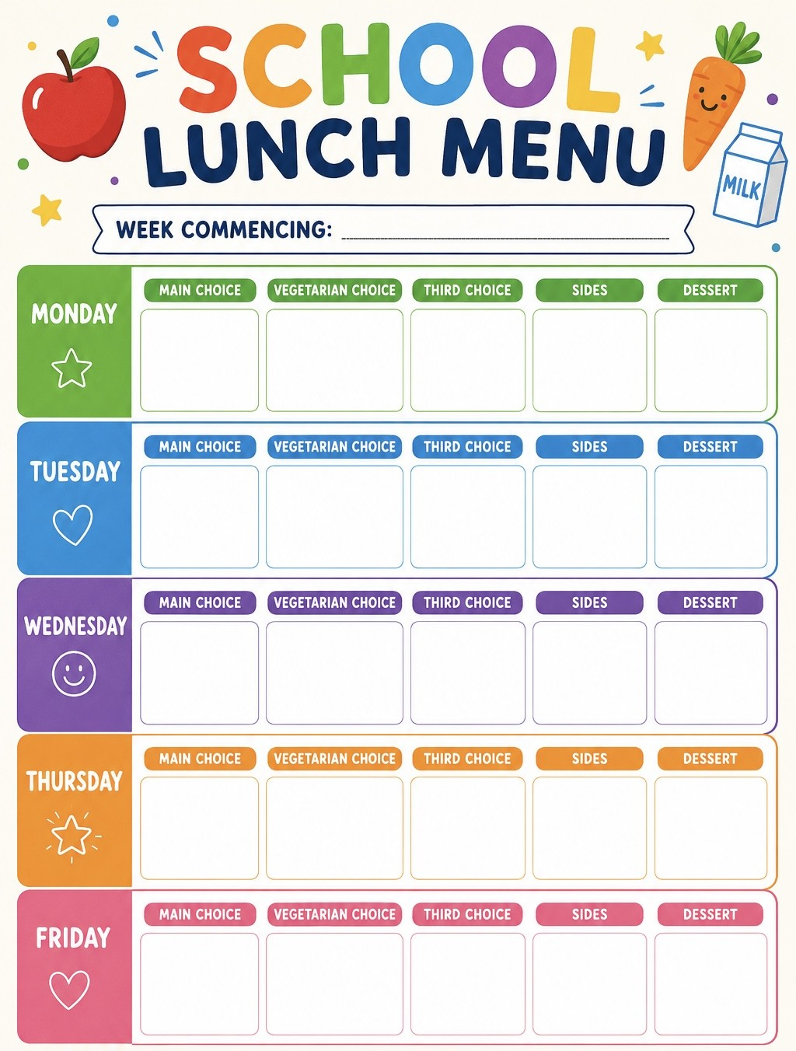
Roast pot/ vegetables/gravy/Yorkshire puddings
Vegetables in tomato pasta sauce
Cheese and bean puff
Rainbow naan pizza
14th Sep, 5th Oct
Chips
Peas
Beans
Chicken and tomato pasta bake
Pasta bolognese
Week
3

Jacket
Potato
Buttery new potatoes
Green beans
Chocolate oatcake
Jelly
Sausage roast dinner
Vegetarian sausage roast dinner
Jacket
Potato
Double ice lolly
Jacket
Potato
Vanilla sponge cake
Summer fruit platter
Vegan sausage roll
Fish fingers
Mixed peppers

Jacket
Potato
Hunters style Quorn fillet
with rice
Garlic bread
Broccoli
Jacket
Potato

