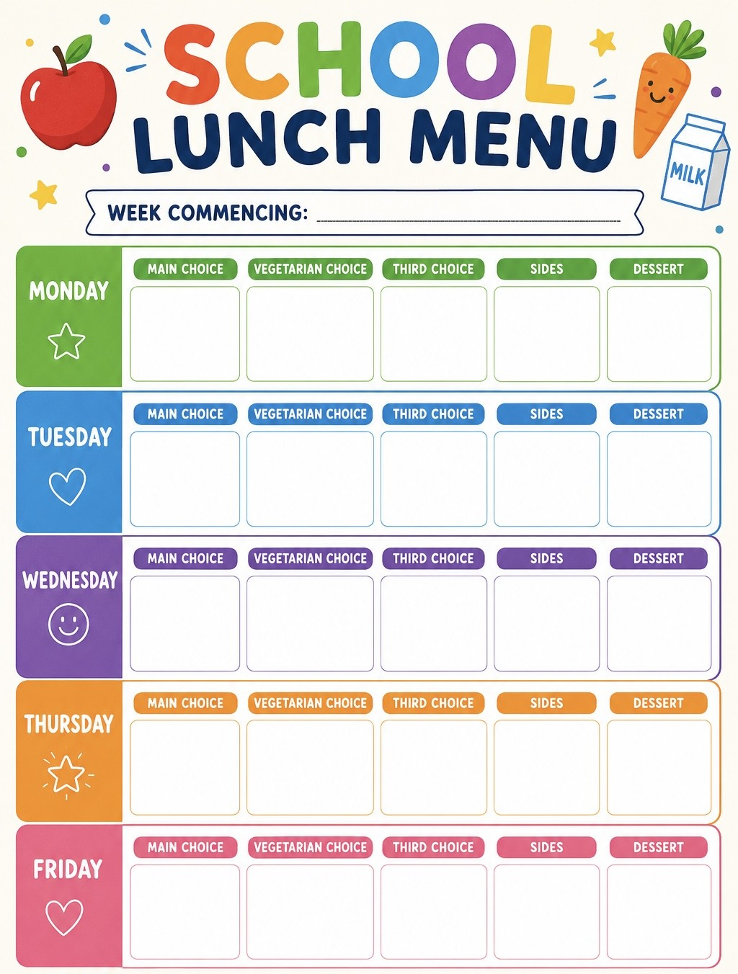
Tortilla chips
Coleslaw
Fruit
Cheese wrap
Hash browns
Beans
Mushrooms
Quorn mince taco
Vegan meatballs with pasta
Macaroni cheese
7th, 28th Sep, 19th Oct
Peas/ crispy cubes/ tomato ketchup
Ham wrap
Pulled chicken taco
Week
2

Jacket potato
Garlic bread
Green beans
Shortbread
Pancakes
Mini all day sausage breakfast
Mini all day vegetarian sausage breakfast
Jacket potato
Fruit ice lolly
Jacket potato
Old school vanilla cake
Summer fruit salad
Quorn dippers
Giant chicken nugget
Jacket potato
Rice/ corn on the cob/ mayo
Jacket potato

