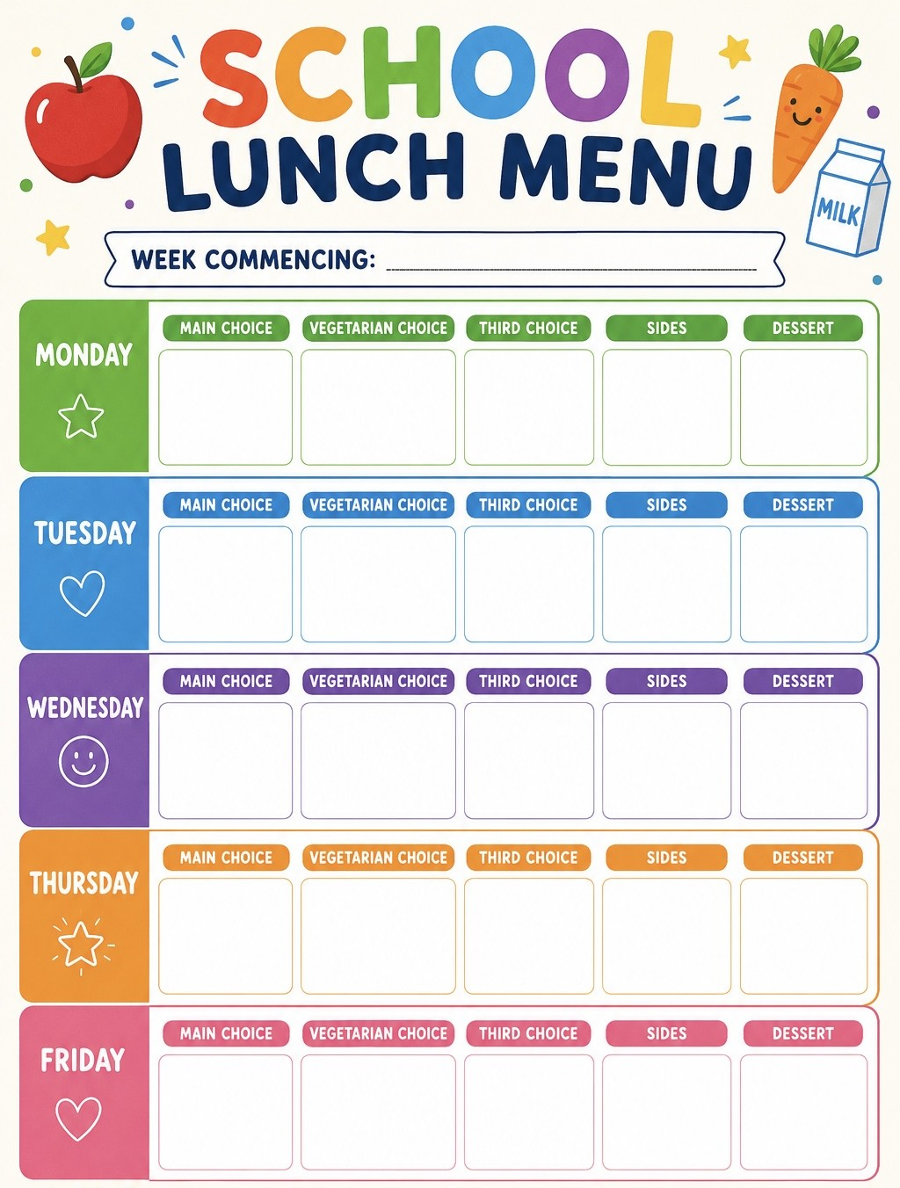
Roast pot/ Yorkshire puddings/ Gravy/carrots
31st Aug, 21st Sep, 12th Oct
Potato waffles/ Peas/ Beans
Chicken curry
Pepperoni pizza
Week
1
Pasta with tomato sauce
Pesto
Pasta
Jacket
Potato
Sweetcorn
Garlic bread
Flapjack
Rice Krispie cake
Roast chicken
Paprika and mixed herb Quorn fillet
Jacket
Potato
Arctic roll
Jacket
Potato
Jelly
Summer fruit salad
Southern style Quorn burger
Sausage
roll
Rice/ broccoli/ Naan bread/ Garlic bread
Jacket
Potato
Curried vegetable puff
Crispy cubes
Coleslaw
Jacket
Potato
Cheese
pizza

