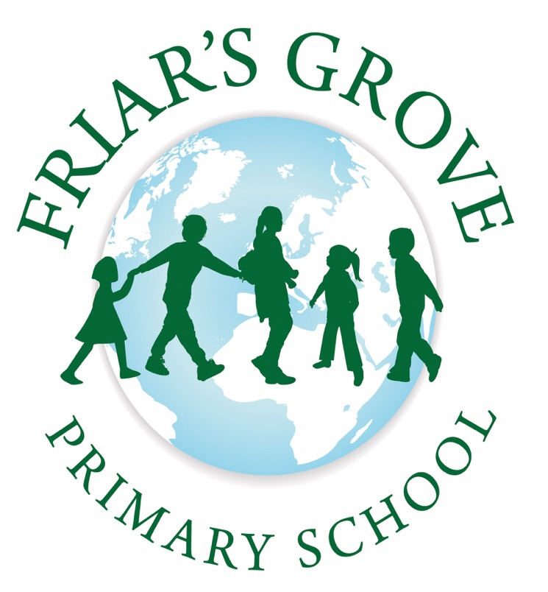

Welcome Booklet

for Parents

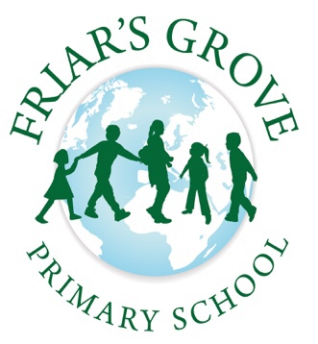

Welcome Parents/Carers,

A very warm welcome to you and your child from the Reception team and everyone at Friar’s Grove Primary School!

Starting school is an exciting event in the life of both child and parent. This booklet is designed to help you and your child learn about our school and answer any queries you may have about starting school at Friar’s Grove Primary School. We hope this will enable the process of starting school to run smoothly, making your child’s first step to independence a happy and enjoyable one.

Our broadest aim in the Reception class is to provide a stimulating environment where your child will find security, be happy and relaxed and develop the correct attitudes towards learning. We also place an emphasis on good manners, encouraging children to be both thoughtful and helpful towards one another at all times.

We believe that it is important for parents, teachers and school staff to work together for the benefit of the child. Therefore, if you have any further queries or questions please do not hesitate to talk to a member of the school staff.

In our Reception classes we aim to:

* Foster the personal, social and emotional well-being in all children by supporting the transition to our school setting
* Enhance children’s social skills, encouraging them to co-operate and work harmoniously with each other
* Extend their learning and understanding in all areas of the curriculum
* Promote attention skills and persistence
* Create independent and enquiring learners
* Build on what children already know at a level that is relevant for each individual as we recognise that every child is unique
* Develop positive relationships with all of our families

The Reception Area consists of two separate but inter-connecting classrooms with access to a shared outside teaching area and garden. Miss April Clark (RC) and Mrs Sara Rahmani (RR) are the teachers responsible for the two Reception Classes and are assisted by Learning Support Assistants (LSAs).

**How will my child learn in Reception?**

In Reception, your child will learn in a very practical, purposeful way. Although we have two classes in Reception, the staff work very closely together and the children will often work across both classes. Your child will learn with either the teacher or LSA, both in whole class or group situations and also through child-initiated activities. We keep our planning flexible so we can always cater for children’s individual needs and interests.

An effective curriculum for young children recognises that they often need to repeat experiences. This is a necessary part of the learning process, which develops confidence and leads to a greater understanding. In the Reception class, we are building on the children's previous knowledge. Practical experiences are valuable and appropriate at this stage of learning. Play provides important opportunities for learning in many ways such as observation, exploration, discovery and communication. Through play, EYFS practitioners will help your child to extend their vocabulary and develop their communication skills. These opportunities are developed through both indoor and outdoor activities.

There are seven different areas of learning and development in the curriculum in Reception and it follows the Early Years Foundation Stage (EYFS) Curriculum from birth to five.

These seven areas are divided into three ‘Prime’ areas of learning:

* Communication and Language
* Personal, Social and Emotional Development
* Physical Development

and four specific areas:

* Literacy
* Mathematics
* Understanding the World
* Expressive Arts and Design

The three prime areas are fundamental to a child’s development and learning and in turn support the development in the four specific areas.

**Personal, Social and Emotional Development**

Self-Regulation, Managing Self & Building Relationships

*****This involves helping children to develop a positive sense of themselves and others and to form positive relationships and mutual respect. Children develop their social skills, learning how to work, play and co-operate with others, and how to regulate their feelings. Children will understand and talk about feelings, learn about 'right' and 'wrong' and develop independence. Their awareness of their health and self-care continues to develop and they are helped to understand the importance of physical activity, and what contributes to a ‘healthy’ life style*.

*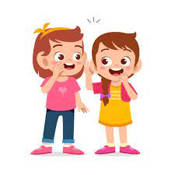***Communication and Language**

Listening, Attention and Understanding

*This will focus on children developing competence in speaking and listening so that they are confident to express themselves and are able to speak in full sentences and listen in a range of situations. Children will make comments about what they have heard and ask questions to clarify their understanding.*

**Physical Development**

*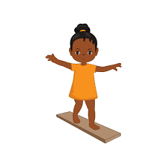*Gross and Fine Motor Skills

*This will focus on children's development of mobility, both gross (larger muscle movements) and fine motor skills (small muscle movements), awareness of space, and manipulative skills in indoor and outdoor environments.*

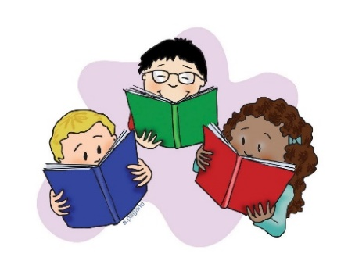**Literacy**

Comprehension, Word Reading and Writing

*This will focus on children developing competence in reading and writing. They will be able to demonstrate an understanding of what has been read to them. Children will learn to recognise their own written name and some familiar words and show awareness of some of the different purposes of writing.*

**Mathematics**

bd05092_Number and Numerical Patterns

*This will focus on children being provided with practical activities*

*to help them compare, sort, match, sequence and count. Through such*

*first-hand experience, children will develop an understanding of*

*numbers and will learn to record and use the appropriate*

*mathematical language involved. They will have opportunities to develop their spatial reasoning skills across all areas of mathematics including shape, space and measures.* *Number rhymes, songs and counting games form an important part of daily activities.*

**Understanding the World**

Past and Present, People, Culture and Communities and The Natural World

*j0397528[1]This will focus on children's developing knowledge and understanding of their environment including their families and communities, and features of the natural and made world. Children will be able to explain some similarities and differences between life in this country and life in other countries. They will explore the world around them and talk about their observations and be encouraged to ask questions to gain information.*

**Expressive Arts and Design**

Creating with Materials and Being Imaginative and Expressive

*This will focus on the development of children's imagination and their ability to communicate and to express ideas and feelings in creative ways. Through art, music, dance, stories, construction and imaginative play, children will develop an increasing ability to use their imagination, to listen and to observe.*

**What is a typical routine in Reception?**

|  |  |
| --- | --- |
| 8:45 | School begins with registration and phonics |
| 8:45-10:30 | A variety of activities e.g. number based |
| 10:30-10:45 | Break time with the Key Stage 1 classes |
| 10:45-12:15 | A variety of activities e.g. literacy based |
| 12:15-1:15 | Lunchtime |
| 1:15 | Afternoon registration |
| 1:15-1:30 | Phonics and reading activities |
| 1:30-2:40 | A variety of activities- cross curricular |
| 2:40-3:10 | Story time |
| 3:15 | Home time |

**Cooking**

We cook in Reception once a week every week. The children learn so much from this weekly activity including basic cooking skills, applying maths knowledge, reading and following instructions, scientific principles of cooking and most importantly collaborative working skills.

In order for us to cook every week we ask for a voluntary contribution of £15 a year or £5 a term to allow us to buy ingredients on a week to week basis.

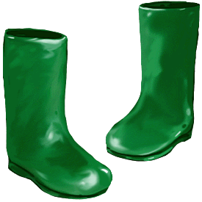**Welly Walks**

One morning a week we walk to the local wooded area, for a session of

outdoor learning.

The children learn to explore natural surroundings, work collaboratively, apply skills they have learnt in the class to other contexts but above all learn to appreciate and enjoy the ‘great outdoors’. The walk to and from the wooded area is well supervised with a safe adult to child ratio. We always appreciate help with these sessions, so if you are free, we would love to have you join us. Please speak to a member of the Reception team about this.

**What items will my child need for school?**

Please ensure that your child has the following to use in school:

* A book bag which should be brought to school every day
* A spare set of clothes, including underwear, in a **named carrier bag** to be kept on your child’s peg
* A pair of wellies and light rainproof jacket to keep in school
* Weather appropriate clothing as and when needed e.g. sun hat, scarf, gloves etc.
* A named plastic cup

**PLEASE MAKE SURE ALL YOUR CHILD’S ITEMS ARE CLEARLY NAMED AND CHECKED REGULARLY**

**When can I discuss my child’s progress with the class teacher?**

You have the opportunity to formally discuss your child’s progress in Reception at our twice-yearly Parent Teacher meetings held in the Autumn and Spring Term. As we are an open school we always endeavour to make time to discuss your child’s progress on an informal basis and we are of course available to talk to if you have any concerns or queries as they arise.

**How can I help my child at school?**

In the Reception year the children are encouraged to have a positive approach to learning and to believe that learning is fun and enjoyable.

Once your child has started school, your

involvement and support remains vital to

their development. Your encouragement

will help your child to settle into school

confidently and happily to show that home

and school are working together.

In order for your child to get the best from

their education we need to work together

to promote a positive approach to learning.

**You can also help your child by:**

As your child grows, they will want to become more independent in their selfcare skills. It may be faster and less messy to do things for your child but they learn so much more from being able to do things for themselves, such as…

**Independent dressing**

You can help by:

• Choosing clothes that are easy to get on and off, such as elasticated waist trousers and skirts.

• Buying shoes with Velcro fastenings.

• Ensuring all items of clothing are clearly labelled with their name and that your child can recognise their own name.

**Eating**

In Reception, all children have a school meal (all children up to and including Year 2 are offered free school meals), so it is important that you encourage your child to practise feeding themselves as soon as they are ready and to be confident using cutlery by the time they start school. If you have a fussy eater at home, don’t panic. It has been shown that children who refuse to eat certain foods at home are more likely to try them when at the school dinner table with their friends.

**Toileting**

Encouraging children to take care of everyday hygiene routines and to use the toilet independently helps them to become more independent and self-sufficient. We hope the vast majority of children are toilet trained before they start with us. Also, encourage your child to always wash their hands after using the toilet.

**Parent helpers**

We value working alongside parents and welcome your interest and involvement in Reception (and indeed throughout the school). Any help you can give will be gratefully received.

Some ways in which you may be able to help in school:

* Helping with reading and sharing stories
* Helping with our weekly cooking sessions or visits to the woods
* Sharing a skill or talent with us such as occupation i.e. firefighter, nurse etc.
* Sharing festivals and celebrations

**Please note that regular classroom helpers**

**will be required to complete a DBS form**

For more information, please speak to a member of staff in the school office.

**How can I help at home?**

**Reading**

* Point out signs, words and print in the environment around them
* Select a wide range of books to share with your child, perhaps visit a library
* Read to them and encourage them to join in with any repeated phrases
* Talk about the pictures and encourage them to tell the story in their own words
* Ask questions about the story as you read, e.g. what do you think will happen next?
* Let your child hold the book, show them how to hold it the correct way round and how to turn the pages from the corner
* Learn any sound and words sent home by practising regularly.

More details about supporting your child with learning to read will be discussed at our Phonics and Reading workshop during the Autumn Term.

**Writing**

* Encourage mark-making by providing a range of items to use, e.g. chalk, paint, crayons and ink stamps while they play
* Show them examples of different writing, e.g. lists, letters, addresses
* Model writing with them in play, e.g. if you are playing shops, say “I think I need to write a shopping list before I visit your shop”
* Don’t spell everything out for your child – let them do it themselves
* Value their attempts at writing and ask them to share what they have written with you
* Always use lower case letters (capitals only as you would normally use them)

**Maths**

* Encourage your child to recognise numbers in the environment, e.g. door numbers, bus numbers, telephone numbers
* Count objects when helping set the table for dinner
* Encourage recognition of numerals and name them
* Write numerals down in context, e.g. 5 bananas when writing a shopping list
* Play matching games, e.g. snap, pairs, jigsaws
* Find and talk about shapes in the environment
* Talk about size and shape of things
* Let them see you using money; allow buying of items when you are together
* Talk about the quantity and position of numbers, e.g. Is it more or less than…? What is the next number?

**A final note**

We hope that you and your child will enjoy your time at Friar’s Grove Primary School. If you have any comments or suggestions about this booklet, we would value your contribution.