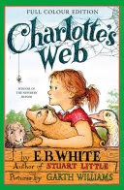
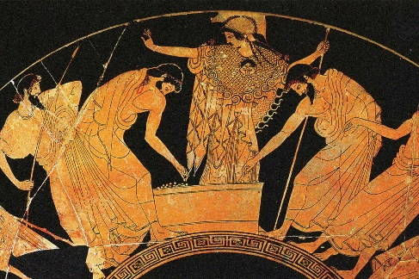
PE
In PE children will be focusing on Yoga. They learn yoga poses and techniques that will help them to connect their mind and body. In outdoor games lessons children will learning and practising their basketball skills such as dribbling, blocking and shooting.
History
This half term, our topic will be, ‘What did the Ancient Greeks ever do for us?’ We will look at the features of Ancient Greek civilisation, find out about Gods and learn about democracy and philosophy.
Computing
This term we will be learning about computer systems and networks. Explaining that systems are built using a number of parts and describing the input, process, and output of a digital system.

French
Children will continue to expand their French vocabulary speaking aloud and in conversation starting with looking at phonetics and a unit on the date.
PSHE
Students will develop the ability to recognise and respond to emotions in others, collaborate towards shared goals, resolve conflicts through negotiation, offer constructive feedback, and listen and respect diverse perspectives while confidently expressing their own views.

DT
Pupils will learn about and make electrical circuits, incorporating a motor. They will design, develop and evaluate a Doodler, an electrical device that uses a motor to draw circles and patterns.
Reading
Our focus book is the classic fiction text, ‘Charlotte’s Web’ by EB White.
English
This half term children will be continuing to develop their writing skills through:
Biographies- David Attenborough

Music
Children will be learning about music of African origin. Pupils will compose and perform rhythmic pieces of music using given musical conventions found in traditional African music.

Science
Our topic this half term is forces. Pupils will find out about forces including, gravity, friction, water resistance and air resistance. Children will also learn about the use of mechanisms such as levers, gears and pulleys. They will work collaboratively to plan investigations, carry out their experiments and provide evaluations.
Religious Education
This half term, our topic is, ‘Is believing in God reasonable?’ in which children will compare Christian, Humanist, Agnostic and Atheist beliefs. They will answer philosophical questions about the world around them and compose balanced arguments to compare different views.
Maths
Following the White Rose Maths scheme children will be developing their knowledge of place value, including; comparing and ordering numbers up to 1,000,000, rounding and Roman Numerals. They will also be learning mental and written strategies for calculating addition and subtraction problems. Please continue to practise times tables regularly.
Year 5
Curriculum Overview
Autumn Term 1
2025

